MANUAL BOOK

WPTECHNO ONLINE SHOP

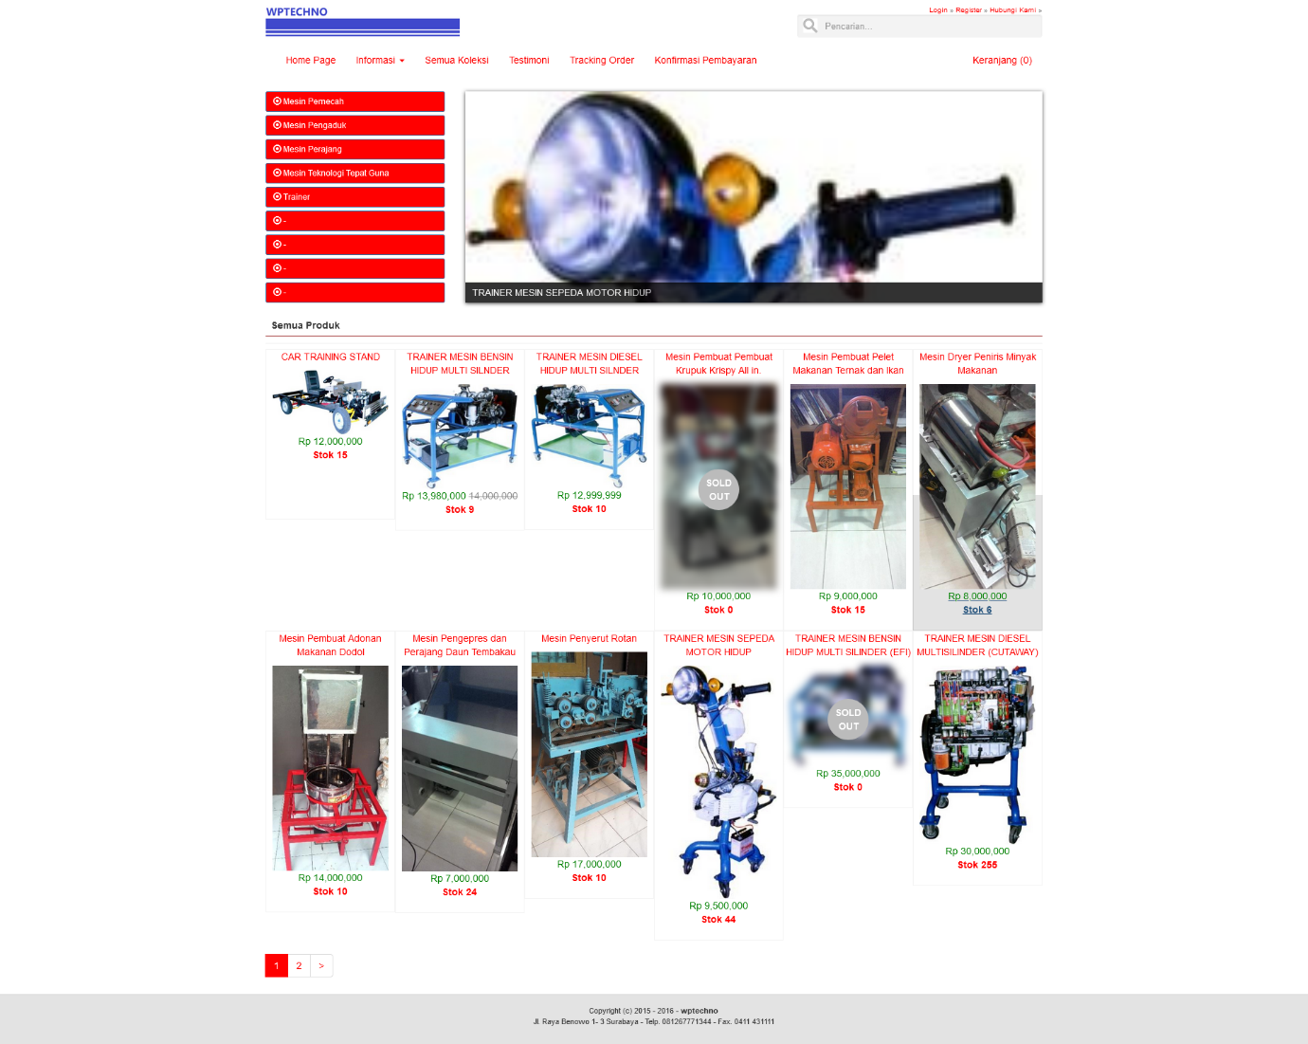

# REQUIREMENT

1. Xampp 7.2
2. Mysql
3. Git

# REPOSITORY

<https://github.com/suryo/wptechno-codeigniter-apps.git>

AUTHOR  
Suryo Atmojo

suryoatm@gmail.com

# INSTALL

1. git clone https://github.com/suryo/wptechno-codeigniter-apps.git
2. create db wptechno on mysql
3. dump sql file -> wptechno.sql
4. setup your config DB on path yourxamppFolder\htdocs\wptechno-codeigniter-apps\application\config\database.php
5. open your browser
6. run url <http://localhost/wptechno-codeigniter-apps/>

# SETUP DB

You can use this setup on your config

$db['default'] = array(

    'dsn'   => '',

    'hostname' => 'localhost',

    'username' => 'root',

    'password' => '',

    'database' => 'wptechno',

    'dbdriver' => 'mysqli',

    'dbprefix' => '',

    'pconnect' => FALSE,

    'db_debug' => (ENVIRONMENT !== 'production'),

    'cache_on' => FALSE,

    'cachedir' => '',

    'char_set' => 'utf8',

    'dbcollat' => 'utf8_general_ci',

    'swap_pre' => '',

    'encrypt' => FALSE,

    'compress' => FALSE,

    'stricton' => FALSE,

    'failover' => array(),

    'save_queries' => TRUE

);

# PAGE

CARA BELANJA

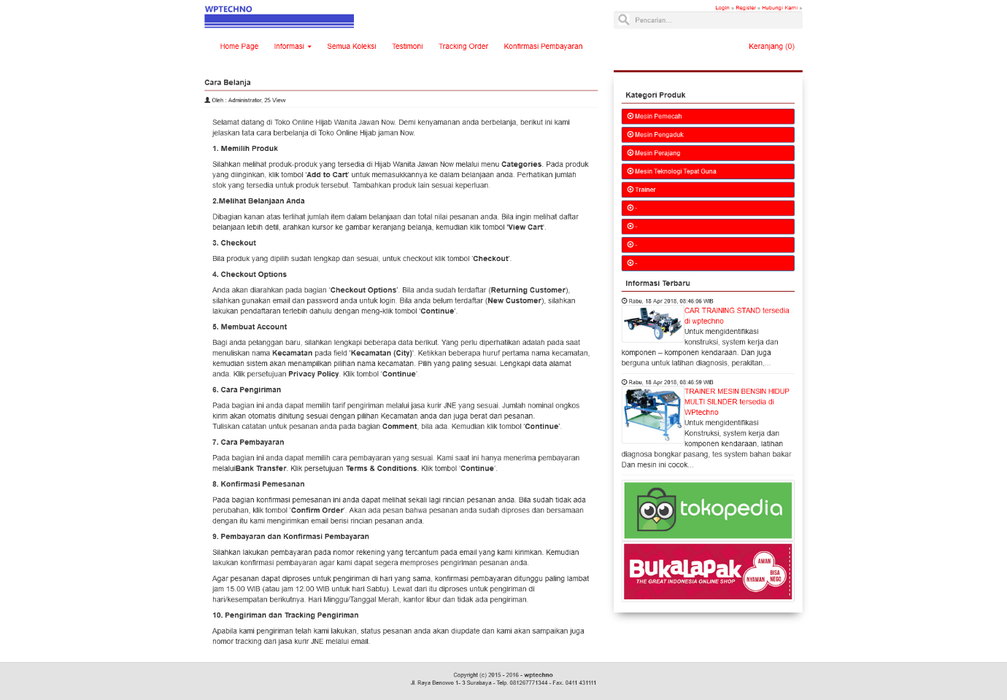

# PAGE

LOGIN USERS

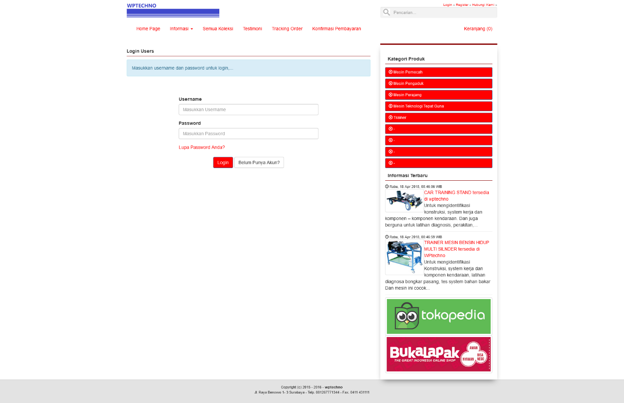

# PAGE

DETAIL ITEM

